Program 11 - Analysis of HR Dataset:

1. Create KPI to show employee count, attrition count, attrition rate, Average Stay at the company ,active employees, and average age.
2. Create multiple donut chart to show the Attrition Rate by Gender for different Age group.
3. Create a Lollipop Chart to show the attrition rate based on gender category.
4. Create a pie chart to show the attrition percentage based on Department Category
5. Create a bar chart to display the number of employees by Age group
6. Create a highlight table to show the Job Satisfaction Rating for each job role based on employee count.
7. Create a horizontal bar chart to show the attrition count for each Education field Education field wise attrition – drag education field to rows, sum attrition count to col,

Link to Download the Data - <https://docs.google.com/spreadsheets/d/1-1Ldoe-DwZTL77tdMtRgZAIzeAzs0jh3/edit?gid=2089618187#gid=2089618187>

U Tube Link – <https://www.youtube.com/watch?v=NC6SOvber8A>

U Tube Link - How to create Bins - https://www.youtube.com/watch?v=7Fcg-Lw7rT8

U Tube Link - How to create Lolly Pop Chart <https://www.youtube.com/watch?v=CB4SKClZTgs>

**How to Load the data**

* Open a blank report
* click on to get data
* click on to the file path
* click on to Load

**How to Check the Data Type**

* Click on to Report view
* Click on to the Icon on the tool bar, Use the power BI query editor to transform the data
* We can see the data type, is there any null values, if you have made any changes, then click on close and apply

**How to Give a Canvas Settings**

* Click on the formatting pane, select the canvas settings, select the appropriate colour, and make the Transparency percentage 0.

**Create KPI to show employee count**

* Click on the card from Build Visuals
* Add the field Sum Employee count
* Click on the formatting pane
* On visuals, select Background off,
* Make Title on, give the title appropriately, make it Bold, align it Centre,
* Make a divider, give the color and style according to your choice, This will provide a line after your title.
* Select the icon call-out value, and change the size, and colour, this will give the Styling of the values written as Employee count.
* Select visual border on , Select the color and shape of the border, this will give the border to your text.

**Create KPI to show attrition count**

First, we have to create a new column, which will give a binary encoding for the column called Attrition. If the value is yes we give the coding a 1, else 0.

* Click on Table view, Click on Transform Data,
* Click on to Add column, click on to conditional column, give the column title as Attrition count,

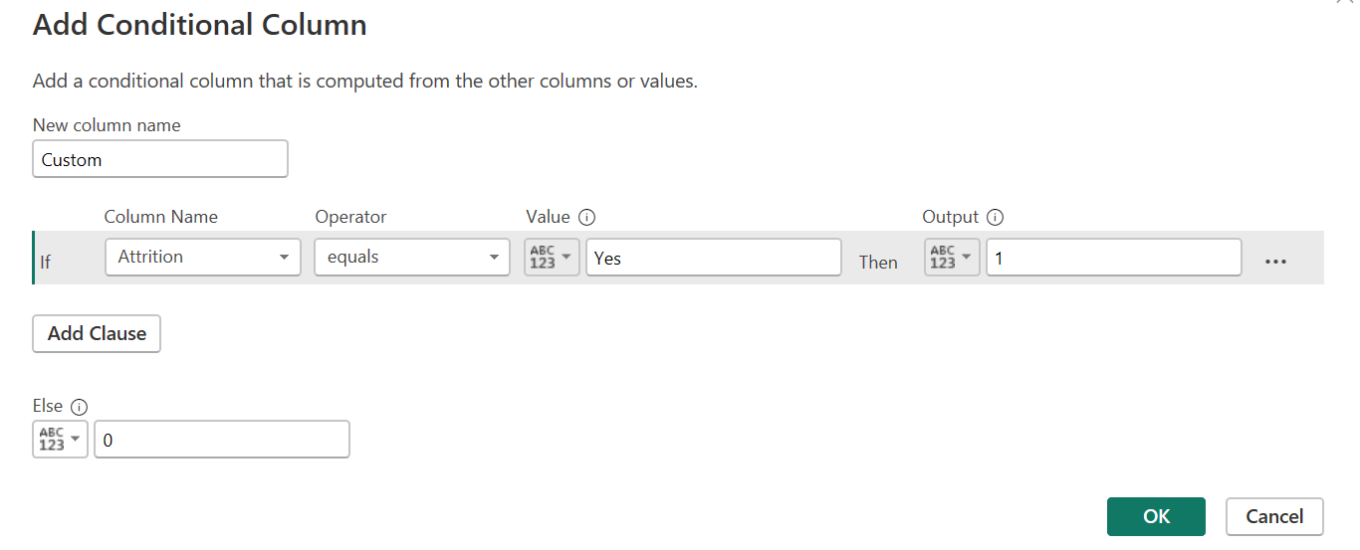

* Change the data type as a whole number, then close and Apply.
* Now select the card from Build visuals, add the Field Attrition Count
* Do the formatting as before.

**Create KPI to show** **to show attrition rate**

* Click on to create a new measure, either clicking on the tool bar, or clicking on to the dots in the data pane
* Give the title as Attrition Rate, Give the formula as

Attrition Rate=Attrition Rate = DIVIDE(SUM('HR data (2)'[Attrition count]), SUM('HR data (2)'[Employee Count]), 0){If you get some unstructured values it will take the value as 0 , for that we have the 0}

* Select a card from Viuals, Select the New Measure Attrition Rate
* The answer will be in decimal, we have to make it in percentage, so change the data type, click on to the % Symbol on the toolbar

**Create KPI to show Average stay**

* Take the new card from visuals
* Add the field Total Stay and change it to Average

**Create multiple donut chart to show the Attrition Rate by Gender for different Age group.**

* First we will create age bins with the help of Power BI Querry editor.
* Click on to Transform Data
* Click on to New Column
* Give the title a Age Bins and Type the following IF Else Condition

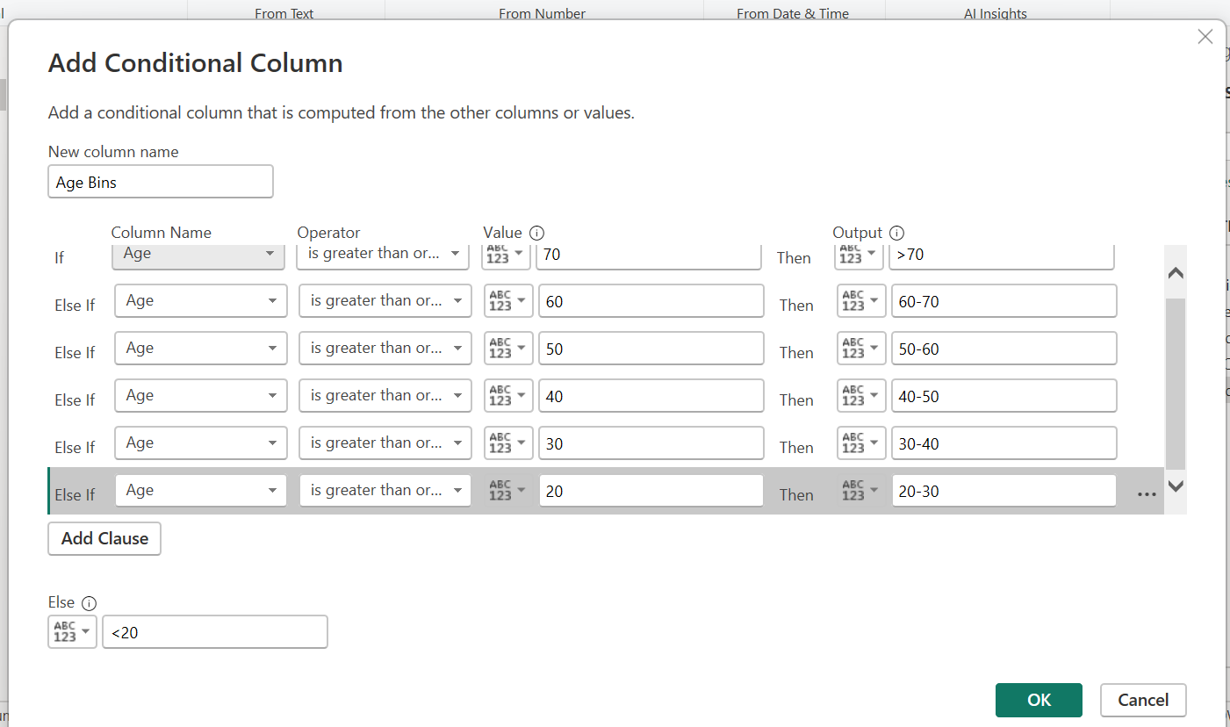

* Press OK , Click on Home and press Close and Apply

With this, a new column will be created in the Table.

* Select Donut Chart from Visuals,
* Place Gender on Legend.
* Place Attrition Count on Values
* Place Age bins on the Filters and Choose the filters depending on different Age group

**Create a Lollipop Chart to show the attrition rate based on gender category.**

* The lollypop chart is not inbuilt in Power BI.
* Click on Options, Click on Preview Feature, Enable On-Object Interaction
* Select Line Chart
* On the X-axis place Gender, on Y axis place Attrition Count
* Click on Visuals, Click on Error Bars
* On the Upper bound option select sum Attrition Count
* Create a new measure called Lower Value and assign it as 0
* On the Lower bound option on Error Bar select the new measure that we have created as Lower Value
* Also Enable the Error Bar Option On. Then we get the graph a shown below

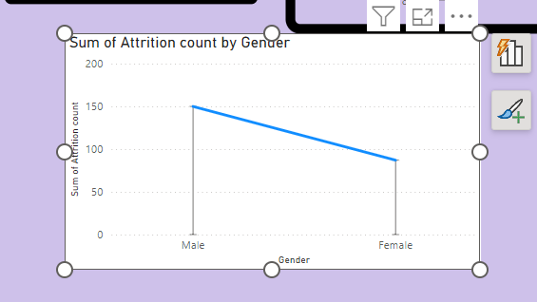

* To make the upper part a Circle, Go to Markers, Enable, show all category labels, select the marker as a circle, and increase the size appropriately.
* To remove the line connecting two bars, go to lines and enable the option off.
* To make the lines bit more bigger, Click on to Error Bars, Click on to the Bar, Make the width of the bar bit more bigger, and change the color according to the choice.
* Make Grid Lines off.

**Create a pie chart to show the attrition percentage based on Department Category**

* Select Pie Chart from Visuals
* Add Department to the Legend
* Add Attrition count to the Values

**Create a bar chart to display the number of employees by Age group**

* Select Bar Graph from Visuals (second Graph from Visuals)
* On the X axis select Age Bins, On the Y axis, select Attrition Count. Apply setting to Categories to change the color of the bars
* Change data Labels on to give the write-up on the top of each bar.

**Create a highlight table to show the Job Satisfaction Rating for each job role based on employee count.**

* Select Matrix from Visuals
* In Rows place Job roles
* In columns place Job Satisfaction Ratings
* In values place Employee count

**Create a horizontal bar chart to show the attrition count for each Education field Education**

* **Select Bar graph from visual**
* **Select Educational field on X axis**
* **Add attrition count on Y axis**

**How to Give the Title for Your Dashboard**

* Align all your earlier visuals and make some space on the top of your dashboard
* Click on to Text Box from the top Tool Bar. Give the appropriate title for your dashboard. Do the formatting as usual

